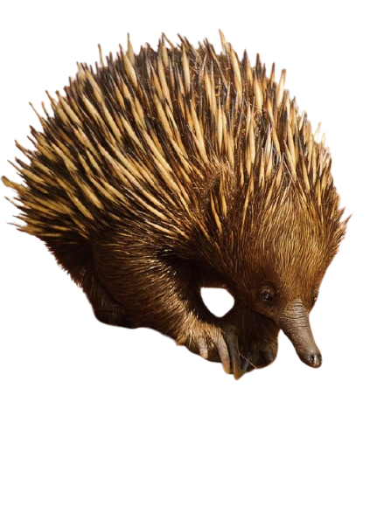
SPINY ANT-EATER IMAGE
SPINY ANT- EATER
Rose Moraa

